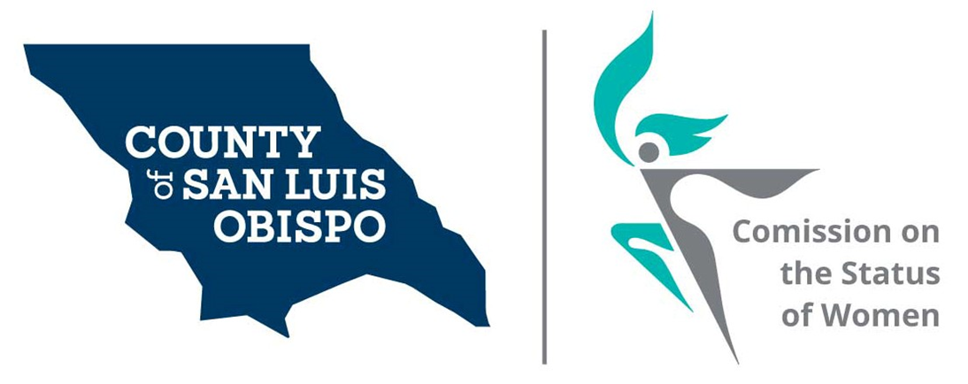
Meeting Agenda
July 7, 2020 @ 5:30 PM
Zoom meeting
- Call to Order

- Roll Call

- Guest(s), Introductions, Announcements

- Guest speaker: Becky Gray, Executive
Director MUST Charities

- Public Comment

- Approval of Meeting Minutes for June 2020

- Treasurer Report

- Commissioner Vacancies – SS
- District 2 – Bruce Gibson - One Commissioner needed
- District 3 - Adam Hill - Two Commissioner needed
- District 5 – Debbie Arnold – Two Commissioner needed
- P.O. Box Mail pick up.

- Social Media and other Communications (Stacy)

- Women’s Issues Survey Numbers Update (Megan)

- Board of Supervisors Agenda Highlight.

- 2021 Women’s Wall of Fame (update) May 8th 2012 at Madonna Inn in secret garden

- Adjourn

