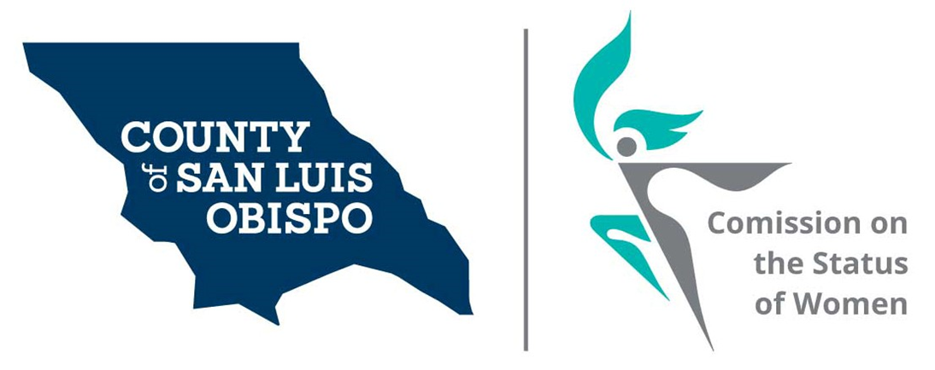
Meeting Agenda
December 1, 2020 @ 5:30 PM
Zoom meeting
- Call to Order

- Roll Call

- Guest(s), Introductions,

- Public Comment

- Approval of Meeting Minutes for October 2020

  - New roster

- Treasurer Report
  - Balance
  - Budget

- Friends of the Commission

- Commissioner Vacancies – SS
- District 3 - Adam Hill - Two Commissioner needed
- District 5 - Debbie Arnold – Two Commissioner needed
- District 4 – Lynn Compton – One Commissioner needed

- Social Media and other Communications (Stacy)

- Action On results of Survey (Stacy)

- Women’s Issues Survey Numbers Update (Megan)

  - Paper Surveys
  - Zoom meeting to review the survey.

- Board of Supervisors Agenda Highlight. (Dixie)
- Holiday Zoom party

- 2021 Women’s Wall of Fame (update) May 8th, 2021 at Madonna Inn in secret garden

  - Working with your excel contact sheets
    - How we are going to use this list.
  - Budget
  - Report from committee

- Adjourn

