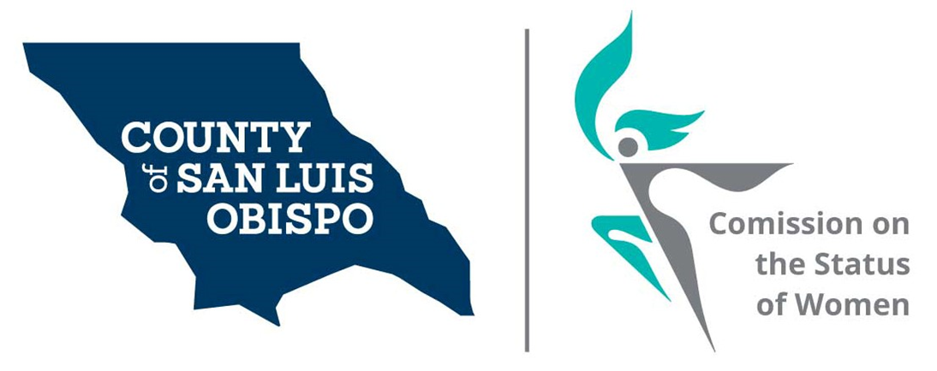
September 1, 2020 Minutes

- Call to Order
Paulla Ufferheide called the meeting to order.

- Roll Call

Commissioner (Initials) | District | Present | Excused | Absent
Nancy Fiske (NF) | 1 | x
Meghan Madsen (MM) | 1 | x
Maria Escobedo (ME) | 1 | x
Paulla Ufferheide, (PU) | 2 | x
Dixie Walker (DW) | 2 | x
Beverly Abrah Younger (AY) | 3 | x
Kathy Veder (KV) | 4 |  | x
Stacy Meko (SM) | 4 | x
Lorna Glenn (LG) | 4 | x
Shirley Summers (SS) | 5 | x
Paula McCambridge, Visitor |  | x

- Guest(s), Introductions,
Dr. Leola MacMillan, Director, Resource Development, United Way of SLO

- Guest Speaker Comments:
Dr. MacMillan noted that she is a feminist, and that her work is dedicated to girls, supporting healthy environment, in schools, in workplaces, or anywhere that “girls breathe.” She learned early on that the work that she does “is often very lonely, especially now that everyone is also very removed from each other. It is easy to lose hope. The work that we are doing can lead to a critical mass and turn the tides. There are days that it is just not happening fast enough. She thanked COSW for the work that we do.”

She has a PhD in American Studies from Washington State, focused on adolescent development, within marginalized girl populations, non-white girls, girls at the margins of society, and those not often seen in academic literature. Representation of difference and the stories that are told through movies and magazines, and what are the stories that are being told is a part of her focus. She is the daughter of two college kids in North Carolina, and believes she has activism in her blood. She shared a lot about her family and her personal life.

Paulla asked about her relationship regarding the United Way, specifically asking “the question is where is United Way right now and how can we collaborate or work with you.” The woman who she previously worked with is now at the United Way. They are committed to dismantling the structure as it was, and creating new solutions. She has had several ideas, yet then some tension arose, and they asked if the focus could be on equity, diversity and inclusion. The approval to do so came through on Juneteenth to move forward with the program, working through a social justice frame. A corollary activity was to establish a social justice fund, called the “Liberty and Justice for All Fund.” Her title has changed since then, but they have not created a title that encompasses what she will be doing.

The project she is most proud of is working on a campaign to change public education by working with structural changes. When the government is charged to change the problem, they have to identify what is the exact problem, and change the structure and the institutionalized realities. The precedent is set. She raised the questions, “What about reparations?” She noted that the COVID check is a type of reparations. She put together a working group, and will work with SLO City, City of Paso Robles, Paso Police Department, County Public Health-, etc., and all of the organizations that the United Way works with, or that she has a relationship with. She listed several state and county organizations involved in governing and funding services in California.

She also has a relationship with Salud Carbajal. She noted, “If we present a plan and show widespread support and go to Sacramento, and if we have a delegation together, and we all say this needs to happen, we will sign this into law. Once the health crisis is declared, how do you implement the change? We need to invent that, and the plan for the city is not necessarily scalable, particularly for the state of CA. Historically, California is the most progressive state, and sets the tone for the rest of the nation.” This is the initiative she is most proud of.

She is doing AMA [?], film discussions, and socially distanced community activities outdoors to engage family and communities, throughout the county. A film called “Today,” regarding programs for youth, steers kids away from gang violence, working with a community gardener, state parks, state government, to connect youth with being outside and being active, and planning native plants and environmental stewardship. One is a yard mapping program, to map yards in their neighborhoods to create gardens in each of the schools in our county, such as the medicinal garden, the native plants garden, and the kitchen garden. This helps them to understand there is stewardship. There is a radio station down in Grover Beach.” We are open to anything, to partner with anyone who want to so social justice work.”

Paulla indicated that some of us may want to participate and to send us the specific options, and we can individually respond. Advisors who can speak to the County and share what we are doing and gain their support. Independently, we can also volunteer or get involved, no matter how tangential. Paulla noted that “We (COSW) are happy to work with you.” Stacy indicated that we may look for a project that we can advocate for and also partner with United Way on.

Dr. MacMillan noted that she would really like to see our survey, and to gain an understanding of what kind of information will be available. She also commented, “What is next? A public health crisis, once it is declared, we will develop a plan and set up a triage process, addressing PTSD and racial trauma, more healthcare, more free services. Setting priorities are important. We don’t need the legislation laid out when we begin the process, but we need some ideas and experts. The Federal level assistance would help to bring people in, through payment to help move the work forward.”

“There are a host of issues all connected to structural inequality, so addressing the majority of them is important. The magnitude of what I am trying to do is overwhelming at times. Yet, at some point we can create a generation of women and girls who never have to endure what we have endured.”

“The Liberty and Justice for All Fund is an opportunity to be the resource for anything related to Equity, Diversity and Inclusion. It can help make the work they do intelligible to everyone.” She is also writing more grants and could use help with the grant-writing. SLO Volunteers website is also something she is taking responsibility for. She described her role as like a community concierge.

- Public Comment
None.

- Approval of Meeting Minutes for August 2020
Dixie Walker had previously shared some minor revisions for the minutes, and Abrah Younger, Secretary, confirmed that the changes were included in the revised version of the August minutes. Dixie moved to accept the minutes. Shirley Summers seconded. All approved.

- Treasurer Report – Shirley Summers reported
Monthly Bank Totals
COSW Account: $2301.61
Friends Account: $2811.83

Shirley discussed modifying our form for reimbursement. The goal is to send the ideas for modification out with the form and discuss what types of changes we may need. Shirley is the Treasurer for the Friends of the Atascadero Library, and they fill out a reimbursement form, and attach their receipts, and if over a certain amount, it requires the President’s approval, which is then sent to Shirley and she keeps that record along with the receipts.

Dixie agree to work with Shirley on the form and share it with everyone to review.

- Friends of the Commission
A meeting was attempted, because Chris is working on the forms needed to solidify our status. Paulla is not aware of where she is at this time regarding the non-profit status forms complete.

- Commissioner Vacancies – SS
Commissioner vacancies include District 3 - Adam Hill, in which two Commissioners are needed. There is a forum being hosted, with four or five individuals from whom commissioners may be selected. The date for the forum is 9/2/20, hosted by the NAACP and the League of Women Voters, with 6 applicants. Check to see if it is being recorded. The meeting is virtual, from 6:30 to 8:30 pm. The League of Women Voters has the information on their website. It is important that we take an interest in the process.

In District 5 – Debbie Arnold, two Commissioners are needed. Shirley Summers submitted an email to the Atascadero AAUW President, describing the position and requesting that interested persons apply. This information was sent to all members in the newsletter. She also submitted a request to the Atascadero Democratic Club. One person expressed interest. Stacy recommended reaching out to the Latino Council to see if they have anyone who is interested, and Stacy agreed to do so.

In District 5, Lorna Glen has resigned due to family concerns, which has prevented her from participating. She is welcome to return.

- Social Media and other Communications (Stacy Meko)
The Women’s March interview with Meghan is coming up soon, and it is a Zoom meeting, and we may introduce ourselves. Paulla will provide information on attending it. The date is Wednesday, 9/9 at 5:00pm. Should one of us be involved with them formally? It would be a good idea, yet Paulla is not sure how they select their Board members.

Maria recommended having a liaison that could connect with the Women’s March, to stay informed. Paulla requested if Meghan would do this role, as a liaison. Stacy noted that there is a team of leaders, and their website keeps information up to date.

- Women’s Issues Survey Numbers Update (Meghan Madsen)
Stacy had shared an idea with Paulla, that we spend some time with our 2019 data, and possibly looking at 2020 data, and brainstorm some things, such as advocacy projects to bring attention to the supervisors or to put our weight behind. Perhaps working with Leola (today’s speaker), for equity and injustice for girls, or the women’s march to support what they do, to partner with them. Shirley noted the 2019 surveys should be used to help us create our focus. In this time of COVID, we have to be creative in our actions.

Whoever is interested, we can look at the survey results, and have a sub-committee Zoom meeting. Paulla will send the results of the survey to all of us. We are limited by what we can do physically due to COVID. Their data is related and supportive of our data as well. Stacey Meko will take the lead in creating a meeting for our members who are interested in discussing this.

- Speaker Concerns (Meghan Madsen)
Meghan Madsen recommended doing an interview format for our COSW meetings, with specific questions, and a time format or limit for our speakers as well. Paulla recommended doing a speaker meeting every other month. Upcoming speakers are booked on October and November, but it could be changed. Paulla proposed leaving these two months’ arrangement as they are. In December, we could shift to every other month, and we can adjust the agendas to shorten them during speaker meetings.

Paulla discussed some ideas on how to best utilize a meeting, such as utilizing a timekeeper and having a set format for the interview. Paulla recommended creating an outline and format, and setting limits or the type of information to present within the timeframe. Nancy Fiske will send an example of this type of format.

Paulla also proposed having a shorter agenda on the nights we have a speaker. Paulla indicated that if we have a speaker that we want to provide more time to, we could create a special longer meeting for this. Nancy will leave both speakers in place for now. Nancy noted that she appreciated the dialogue on addressing the length of presentations and impact on the meetings.

Stacy also discussed the idea of inviting others to participate with our shared speakers, how to get PR [Public Relations] and a mailing list. We might need an email marketing resource or put all of the names into our Gmail addresses.

Meghan provided an update on the number of completed surveys, which currently include 170 surveys
completed on Survey Monkey. She asked those present to send any other surveys received.

- Board of Supervisors Agenda Highlight. (Dixie Walker)
Dixie reported. Also on 8/11, Rita O’Neal was reappointed. August 18th, the request to reappoint Paula McCambridge was passed. In September, on this date (today), there is a request for a substance abuse/opoid program for $900,000, listed as Item 5. Also, they are deleting two behavioral health workers and expanding a behavioral health specialist, listed as Item 6. Funding is provided. They want to accept CA CDC Coronavirus Aid, projected funding $266,766 for enhanced contact tracing (under health), under social services consent agenda, the contract approval for subsidized youth employment services, for $550,000, and Workplace Opportunities for $532,711 (Item 7).

- 2021 Women’s Wall of Fame (update) May 8th 2012 at Madonna Inn in secret garden
Paulla noted that she and Shirley met last month and created a theme for the 2021 Women’s Wall of Fame, which is “Women’s Hopes Spring Eternal.” Feedback included that it is “hopeful” but not action-oriented. Paulla noted that this is a “working title.” A suggestion was made for each of us to consider other wording or phrasing for the event’s title. The speaker is set, and she is Jill Bolster White, Executive Director of Transitions Mental Health. She is a highly respected woman leader within our community.

Regarding the Wall of Fame, by January we will want to send out the applications to the non-profits and be starting to get our PR out. In the past, we worked a deal with American Media, and they have a run an ad on all of their stations, with a focus on why organizations should nominate a woman for the Wall of Fame. All of the nominations are in by March, and then invitations sent by April. Abrah is working on the forms and the revisions that are needed and needs to get them out as soon as possible.

Once someone is nominated, COSW contacts them and interviews them to gain information about them that should be considered.

Survey highlight: Nancy has a volunteer to work on the Spanish version of the Survey, but she is not available right now due to family concerns.

- Adjourn
Paulla made a motion to adjourn and all agreed.

